**¶** (60 pt)

**PAPER TITLE**

Paper title formatting: Times New Roman, 16 pt, bold, centred, uppercase. The paper title will be written in English and will contain max. 12 words, avoiding “Study on…”, “Contributions to…” etc.

**¶** (12 pt)

**First Name LAST NAME[1], First Name LAST NAME**[2]

Authors’ names formatting: Times New Roman, 10 pt, bold, centred, first name: lowercase, last name: uppercase

**¶** (18 pt)

ABSTRACT: Abstract title formatting: Times New Roman, 10 pt, bold, uppercase. Abstract text formatting: Font: Times New Roman, 10 pt, justified. The text of the abstract, 100 – 300 words, will be written in English, in a single paragraph. The abstract will include information regarding the entire paper, without being an introduction. It must describe the subject and the objectives and it must mention the conclusions. Literature citations and figure references should not appear in the abstract.

¶ (12 pt)

**KEYWORDS:** 5 - 7 keywords, in English

**¶** (24 pt)

NOMENCLATURE

Nomenclature title formatting: Times New Roman, 10 pt, bold, uppercase.

The Nomenclature section must include the list of symbols and notations used within the body of the paper, in alphabetical order, as follows: capital letters, lowercase letters, Greek symbols, subscripts and superscripts.

¶ (24 pt)

1. INTRODUCTION

¶ (12 pt)

All chapter titles, including the Introduction and Conclusions, will be numbered.

Chapter title formatting: Font: Times New Roman, 10 pt, bold, uppercases.

The paper must be written in English and proofed using English (UK) language.

The paper must present original aspects of your work, bringing technical and scientific contributions in the field. The recommended paper length should be of maximum 6 pages. The authors are fully responsible for the content of the paper.

The papers not respecting the publishing conditions and the topics of the scientific journal will not be accepted.

¶ (6 pt)

* 1. **General requirements**

¶ (6 pt)

All subtitles will be numbered.

Subtitles’ formatting: Font: Times New Roman, 10 pt, bold.

Use this file as a template for writing your paper in **.docx** format. The paper format is A4, portrait (8.27” width, 11.69” height), with the following margins: 0.93” top and bottom, 1.08” inside and outside. The Header for the first page will contain the name along with the current volume and number of the publication: “TURBO, Vol. IV (2017), no. 2”. The Header for the odd/even pages will contain the Paper name, respectively the Authors’ names.

The text body will contain the paragraphs one under the other, starting with 0.5” indent, aligned with the Justify option, with single line spacing, Times New Roman, 10 pt.

The paper will be submitted in **.docx** format.

**¶** (24 pt)

1. PAPER CONTENTS

¶ (12 pt)

The presentation will be clear and concise. The measurement units system used will be the International System.

The paper must detail the following aspects:

1) The approached problem and the purpose of the paper;

2) The state-of-the-art in the field – literature overview, with complete references;

3) The contribution of the authors – research, methods, technical-scientific solutions;

4) The results;

5) Aspects regarding further research.

**¶** (24 pt)

1. EQUATIONS, FIGURES, TABLES

¶ (12 pt)

The mathematics relations will be written in equation editor, 12pt, centred and numbered consecutively.

¶ (12 pt)

$m_{a}=\frac{U_{in,a}}{R_{a}}$ (1)

¶ (12 pt)

The figures must be mentioned in the text body as “Fig. x”, using the “In Line with Text” option and placed centred, on the same page and as close as possible to their reference. They must be sent along with the full paper, in high quality files, suitable for reproduction and print. The figure title must be written below the figure in Times New Roman, 10pt, bold, centred.

¶ (12 pt)

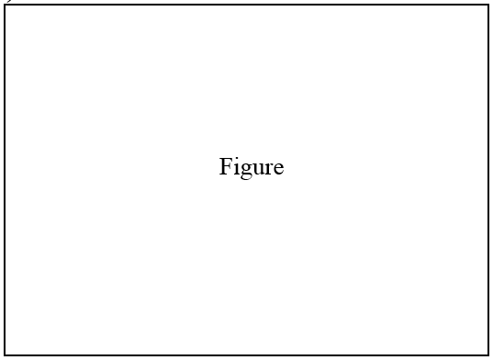

Fig. x Figure title

¶ (12 pt)

The tables must be mentioned in the text body as “Table x” and placed at the top or bottom of the page, as close as possible to their first reference. The table title must be written above the table in Times New Roman, 10pt, bold, justified left.

¶ (12 pt)

Table x. Table title

|  |  |  |
| --- | --- | --- |
| No. | Parameter | Unit |
|  |  |  |
|  |  |  |

**¶** (24 pt)

1. PUBLISHING STEPS

¶ (12 pt)

The publishing steps are as follows:

1. Submission of full paper
2. Evaluation of full paper
3. Authors’ notification of paper acceptance (along with reviewers’ recommendations)
4. Submission of final paper (reviewed according to the recommendations)
5. Publication of the journal

**¶** (24 pt)

1. CONCLUSIONS

¶ (12 pt)

The mandatory concluding section must include a summary of the results and a series of recommendations for further researches.

**¶** (24 pt)

ACKNOWLEDGEMENT

¶ (12 pt)

Acknowledgement title formatting: Times New Roman, 10 pt, bold, uppercase.

The Acknowledgement section will include the names of the individuals, institutions, programmes, etc, which contributed to the work, reported within the text through scientific guidance, material or financial support, etc.

**n¶** (24 pt)

REFERENCES

¶ (12 pt)

References title formatting: Times New Roman, 10 pt, bold, uppercase.

The references will be mentioned in the text body in square brackets and there will numbered, e.g. [1]. The References section will respect the quotation within the text and will be formatted as follows:

Books: Names and initials of authors; year, article title; editors; title of the book (italic); edition; volume number; publisher; place; page number;

Conferences volumes: Names and initials of authors; year; article title; full title; conference abbreviated; volume number; place; date; page number;

Journal papers: Names and initials of authors; year; full title of the paper; full name of the journal (italic); volume number first and last page numbers;

Patents: Names and initials of authors; year; patent title; country; patent number;

Dissertations: Names and initials of authors; year; title; specification; institution; place;

Legal regulations and laws: Abbreviated name; year; full name of the referred text; document type; author; URL address;

Web references: authors name; year; title of the document; full URL address.

Publications by the same author will be listed in order of year of publication. The books and articles published in Romanian will be written in Romanian and translated in English between parentheses

1.
2.